Theatre Arts 2019-2020
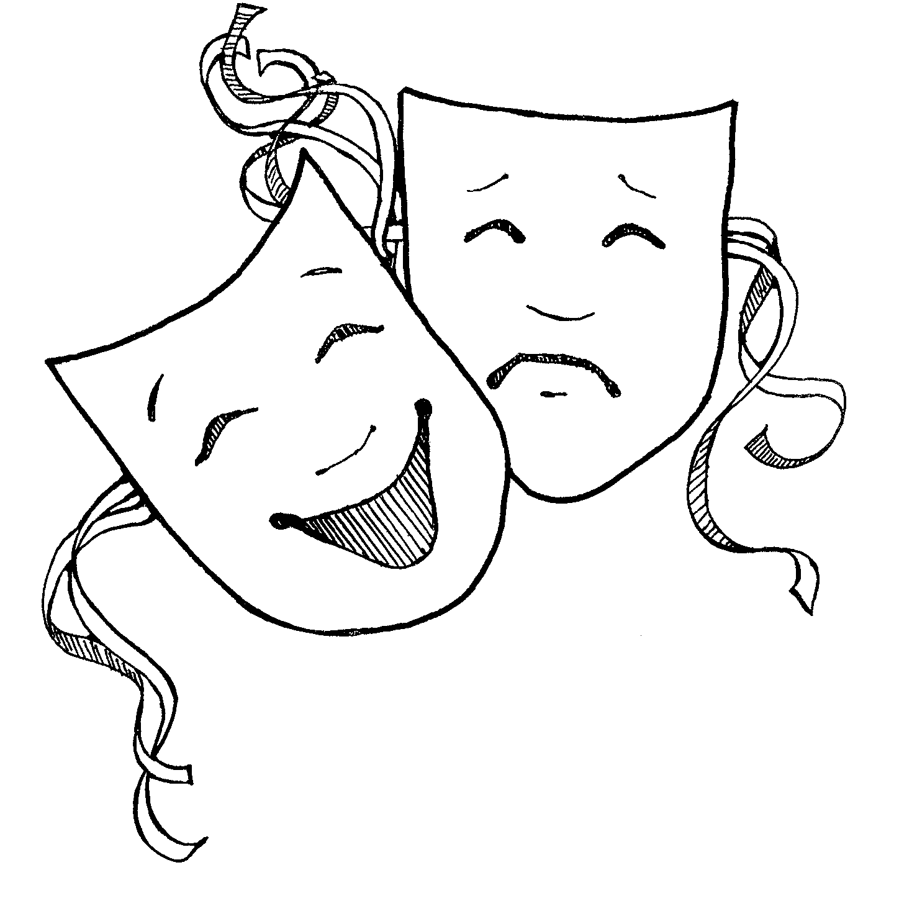
Mrs. Hannah Fry
Website: www.mrsfry.com
Email: fryj@issaquah.wednet.edu
Phone: (425) 837-7777
Office: 2504 (in the Arts wing across from the 2D Art Classroom)

Dear parents/guardians and students:
Welcome to Theatre Arts! Theatre Arts explores a wide variety of areas that make up theatre. While the focus of the course is on the principles and techniques of acting, the course also examines related topics including theatrical design, theatre history, direction, dramatic literature, and related careers.
COURSE CONTENT:

Unit 1 – “The Basics”: Ensemble Development, Warm-Up, Improvisation, The Stage Space & Terminology
Unit 2 – “Elements of Acting”: Audience Etiquette, Pantomime, Voice & Movement, Greek/Roman Theatre
Unit 3 – “Character”: Development, Analysis, The Monologue, Eastern Theatre
Unit 4 – “The Play”: Directing, Blocking, Renaissance Theatre
Unit 5 – “Theatrical Design”: Fundamentals of Design & Technology, Restoration Drama, 19th Century Theatre
Unit 6 – “Production”: Scene Work, Theatrical Careers & Industry, Final Performance

Each unit focuses on a primary aspect of theatre, moving through exploration, preparation, performance, and specialization. Theatre history is sampled throughout the units and moves from Greek/Roman theatre to the 1800s.
- The first semester final consists of a monologue performance portfolio. The second semester final consists of a scene performance with a partner.

Materials: Students will need the following materials in class EVERY DAY. Please obtain and bring these materials as soon as possible.
Excused Absences: Students will be expected to make up all assignments and notes. Homework that was collected during an absence is due within 1 day of the student’s return to receive full credit. It may not be possible to make up some assignments such as Socratic seminars.
**No late work will be accepted for unexcused absences.
**Late work may be turned in for 10% off each day late until the unit assesment. Weekends count as two days late. No late work will be accepted after the unit test. Late work deductions will stop at 50%.
Major Projects: Due dates will be given well in advance. Even if the student is absent on the day the assignment is due, it is the student’s responsibility to make arrangements for his or her assignment to be turned in prior to the absence. If the assignment allows for it, email your assignment so it is on time!
Missing Work: Will be reflected as an * in the grade book until 2 weeks before quarter/semester grades are reported. It will become a zero at that time.
Spartan Support: Spartan support will be assigned when a student has more than 1 assignment missing.

- Writing implements
- A Drama Folder to hold all handouts, scripts, and notes
- Appropriate class clothing to allow for full movement and participation (gym clothes). I will inform you of days in which you will need to change for class.
- Periodically, you may want to have art supplies (markers, colored pencils, etc.) available. I will inform you when such materials will be necessary.
- An assignment calendar or personal planner.

Assignments:
Throughout the year, your primary assignments will be based in performance and participation. However, you will also have a few projects, mandatory production attendance and reviews, and a final small-group performance. Refer to the grade breakdown section for descriptions of the corresponding weights.

Written Work: Please note that all writing assignments (production reviews) MUST be typed.
- Students will complete one production review per Skyline production, which is due the Friday after the show closes. There are three productions per year – one during first semester and two during second semester.
Participation: The presence, curiosity, integrity and cooperation of all students are important to the success of everyone in the classroom. Students will be evaluated on various aspects, which include (but are not limited to):
- Actor and Ensemble Warm-Ups
- Full immersion in improvisational and performance games/activities
- Discussion
- Preparedness for class
- Respect for the teacher and fellow students

CONDUCT POLICIES:
Cell Phones and iPods/Music Players:
Cell phones will NOT be permitted during activities in class. If I see a cell phone being used or hear a cell phone in class I will confiscate the electronic device and hold it until the end of class. Repeated offenses will reflect in participation/performance grades.
Laptops:
- Laptops will not be permitted in class unless we are working with computer carts. Experience and studies suggest that the negatives of laptop use in class outweigh the positives. If you are taking enough notes to need a laptop, you are spending too much time taking notes and not enough time engaging with the material, the teacher, and your classmates. You are also missing the valuable step of synthesis in your note taking.
Gum:
Gum is not permitted in theatre class. We will be participating in physical activities and group movement due to the nature of a performing arts class. You need to use your voice well, and gum impedes that process.

This class is interactive. The more each student puts into the class, the more we will all get out of it.
Attitude:
- Trust and mutual respect are desirable in any classroom but especially so in drama, where students should ideally feel able to experiment, take risks, and share thoughts and feelings.
- Do not think, do; do not tell, show; do not discuss it, make it. Spontaneity is the core of confidence and trust!
- Celebrate failure – goofs and gaffes should be shared and enjoyed in a spirit of adventure and experimentation.
- There will be no distracting noises or actions when a person or persons are performing on stage or in class.
- Participate as part of a team.
- Students are expected to support and encourage their fellow students in classwork.
- Performance and drama can sometimes be a stressful experience. You are expected to be positive and civil with all student-to-student encounters in our class. This is a safe environment where you are encouraged to take risks and grow in confidence and self-assurance. Any negative feedback or criticisms of your classmates is strictly prohibited and will result in punitive consequences.
Make good choices.
Grade Distribution:
40% Participation (Daily Warm-Ups, Activities, Performance Practice, Games, etc.)
- Students earn points for positive cooperation in class activities and a willingness to try, ask questions, and volunteer.
- Students lose points for disruptive/disrespectful behavior, refusal/minimal participation, and being unprepared.
40% Process/Quizzes (Pantomime Project, Stage Directions Quiz, Monologue and Scene Scansion,
Costume Design Project, Theatre History Quizzes, etc.)
10% Production Critiques (see next page)
- There is only one production critique for the first semester; there are two for the second semester. Considering the math, if a student chooses not to complete the assignment he/she will guarantee that he/she will not receive an A in the course.
- The production critique instructions are attached to this syllabus.
10% Final Performances

Grading Scale:
A 93-100  A- 90-92 | B+ 87-89  B 83-86  B- 80-82 |  | C+ 77-79  C 73-76  C- 70-72 | D+ 67-69  D 60-66  F 59 and below
Rounding:
Final semester grades will be rounded up if the raw percentage is within .5% of a letter grade change, and only if the student has no missing projects/tests, production critiques, or final work. No exceptions will be made (including but not limited to extended illness, absences, etc.) as those instances will have already been ameliorated with excused work/late work agreements.

Thank you for your willingness to embark on a wonderful year of theatre!

This contract becomes valid and binding when the student and guardian are affixed to the signature page below. This section needs to be signed by the student and one parent/guardian, detached from the contract, and then returned to the teacher for safekeeping.

The student should obtain all necessary signatures and return this page by Friday, September 13, 2019.

Student Syllabus/Contract Signature Page
Theatre Arts 2019-2020:

I hereby understand and agree to the terms of this contract. I promise to do my best to fulfill the course expectations so that I may gain all of the benefits that are possible from this course. I will strive to attend class regularly, complete all required work, participate in class activities, and I will have respect for my teacher and fellow classmates.

I understand that I have until September 13, 2019 to drop/switch a class without a “W” on the transcript.

Student’s name PRINT:____________________________________________________________

Student’s Signature:_______________________________________________________________
*Student, please update/verify your email address on Skyward.

I have read this contract with my student and I understand the terms of this contract. I agree to provide support and assistance at home for my student as needed. I understand that my signature indicates my approval of units to be studied during this course. I understand that my signature implies my acceptance of the policies described in this syllabus. I understand that I am welcome to contact the teachers at my convenience regarding any concerns or comments.

We understand that students have until September 13, 2019 to drop/switch a class without a “W” on the transcript.

Parent/Guardian’s name PRINT:__________________________________________________________

Parent/Guardian’s Signature:_____________________________________________________________
*Please, update/verify your email addresses and phone numbers on Skyward as well.

